Windstorm
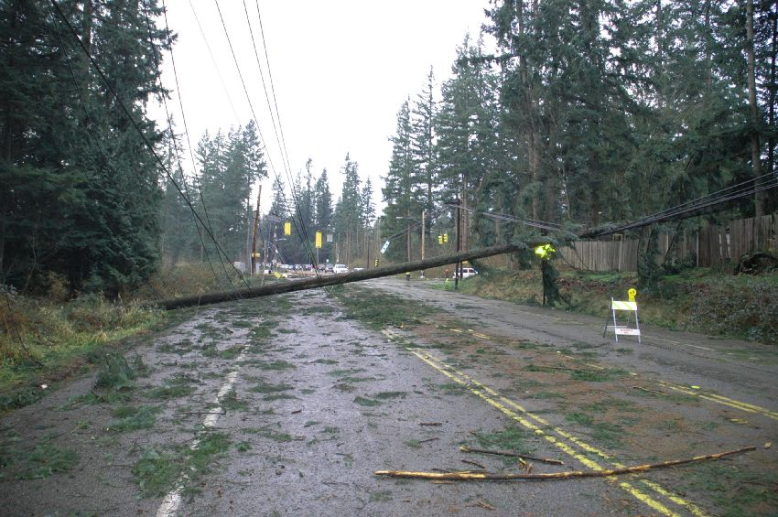
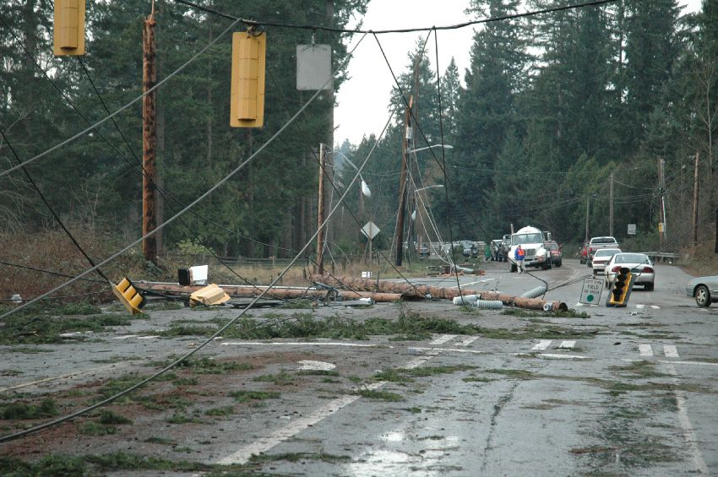
Strong winds that can cause power outages, damage to trees and buildings, and may or may not be accompanied by rain.

Freezing Rain
Rain that falls onto cold ground and freezes once it makes contact. This results in a layer of ice on objects like trees, powerlines, and on the road.
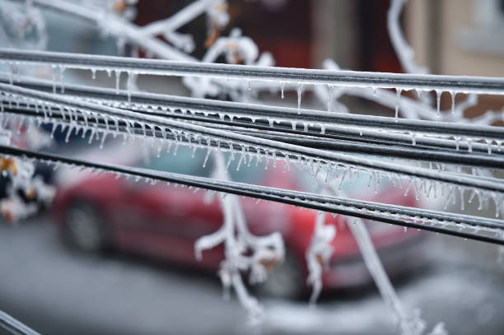
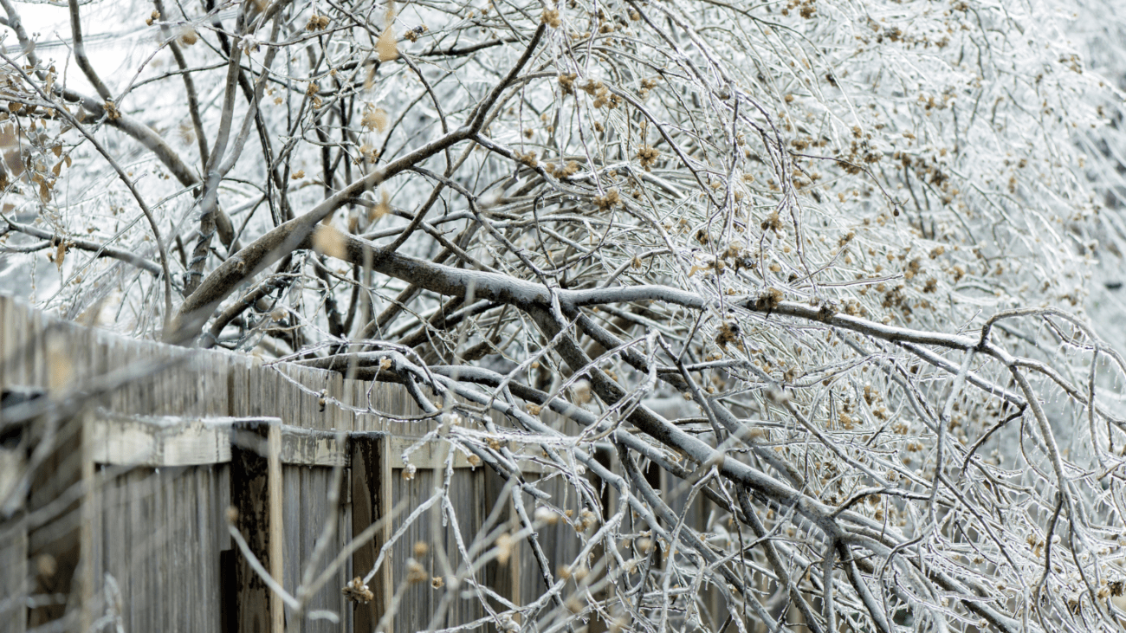

Black Ice
A transparent coating of ice, found especially on a road. It can be difficult to see and make it very dangerous to drive. It does not need rain to form.
